Expt.8

Aim : Implementation of Bayesian algorithm

Theory:

**Naive Bayes classifiers** are a family of “probabilistic classifiers” based on [Bayes’ theorem](https://en.wikipedia.org/wiki/Bayes%27_theorem) with strong independence between the features. They are among the simplest Bayesian network models and are capable of achieving high accuracy levels.

Bayes theorem states mathematically as:  
P(A|B) = ( P(B|A) * P(A) )/ P(B)  
where A and B are events and P(B) != 0.  
P(A|B) is a conditional probability: the probability of event A occurring given that B is true.  
P(B|A) is also a conditional probability: the probability of event B occurring given that A is true.  
P(A) and P(B) are the probabilities of observing A and B respectively without any given conditions.  
A and B must be different events.

Algorithm/steps:

1. Load the dataset and convert it into list.
2. Separating the data as per class(0,1)-mp[0], mp[1]
3. define the test input: test = [2,1,0,1]
4. find the prior probability of each class
5. Find the conditional probability of test for each class-[yes,no]

6) Display the posterior probability of each class and find maximization

Code with output

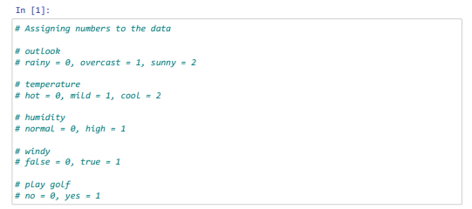

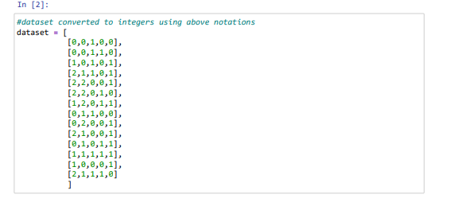

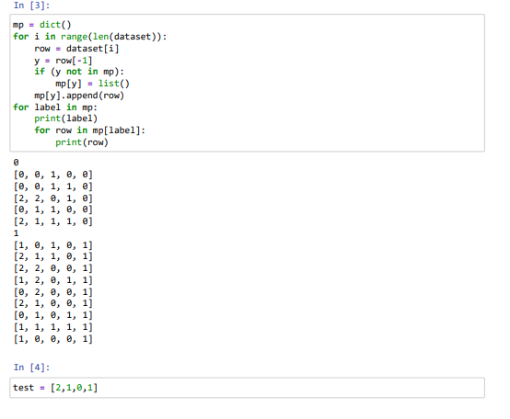

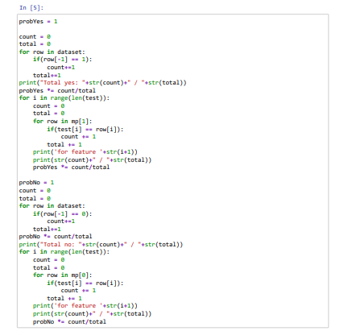

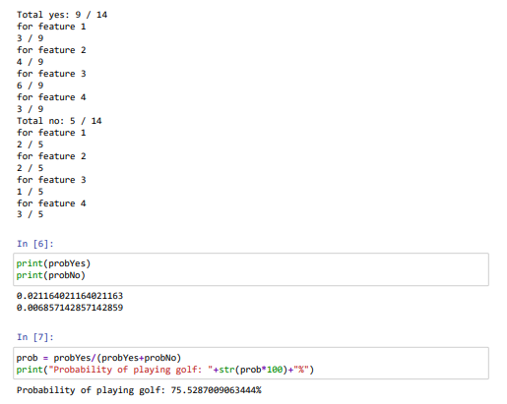

References:

[Naive Bayes Classification Program in Python from Scratch - japp.io](https://japp.io/machine-learning/naive-bayes-classification-program-in-python-from-scratch/)

[Naïve Bayes Algorithm -Implementation from scratch in Python. | by ranga_vamsi | Medium](https://medium.com/@rangavamsi5/na%C3%AFve-bayes-algorithm-implementation-from-scratch-in-python-7b2cc39268b9)

[ML | Naive Bayes Scratch Implementation using Python - GeeksforGeeks](https://www.geeksforgeeks.org/ml-naive-bayes-scratch-implementation-using-python/)

[How to Develop a Naive Bayes Classifier from Scratch in Python (machinelearningmastery.com)](https://machinelearningmastery.com/classification-as-conditional-probability-and-the-naive-bayes-algorithm/)